Header – Alternate Quote

Instructions for creating an alternate quote.

Launch eRapid Quotes from Citrix and select desired user.

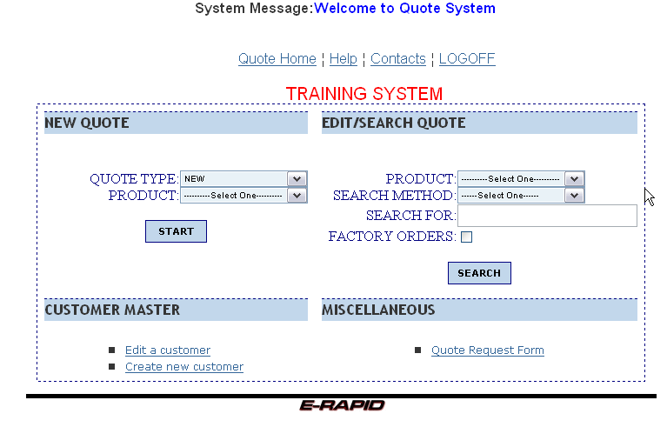

Click on the down arrow for “Quote Type” in the “New Quote” block.

Select “Alternate” from the drop down.

Click on “Product” and select the desired product from the list.

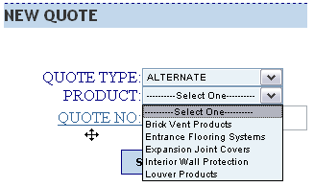

Click on the “Quote No” label and a new window will pop up.

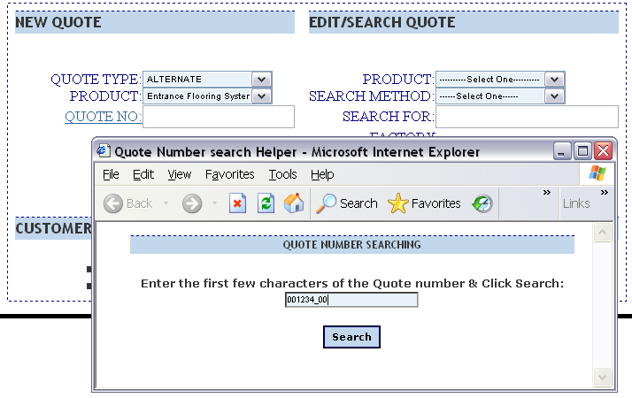

Enter the original quote number. As previously noted, the “%” works as a wildcard for searching.

Click on the “Search” button.

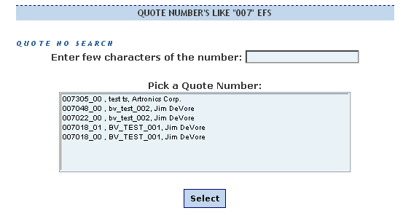

Highlight (select) the desired quote number by clicking on it.

Click the “Select” button and the selected quote number will populate the box on the screen.
Click the “START” button in the “New Quote” block to proceed.

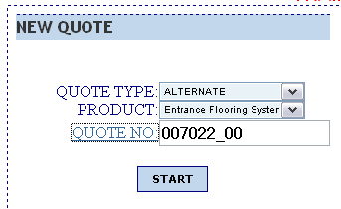

Make any necessary changes to the header.

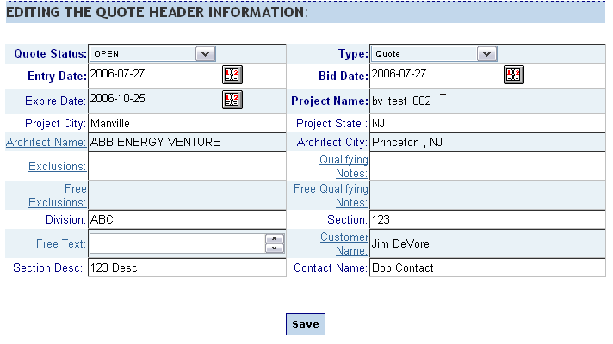

Click the “Save” button to go to the line item screen.

The program will now create a copy of the original quote. Alternate quote numbers will have the same first six digits as the original quote number, followed by an underscore “_” and two digits for the number of the alternate. For example, quote number 001234_00 would have 001234_01 for the first alternate and 001234_05 for the fifth alternate.

End Section

